Community Opioid Outreach Program: A Guardian Mentality Approach to Drug Abuse Intervention and Treatment.

The Police Chief, July 2017

William Taylor, Superintendent, Lowell, Massachusetts, Police Department, and Maryann Ballotta, Public Safety Research and Planning Director, Lowell, Massachusetts, Police Department
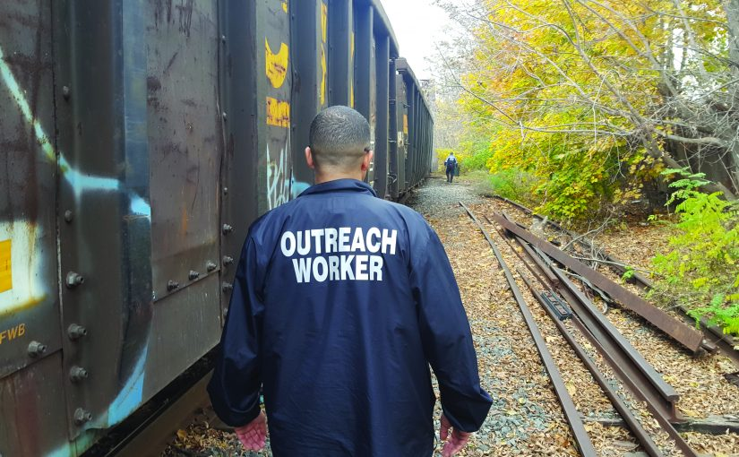
The City of Lowell is the fourth largest city in the Commonwealth of Massachusetts, with more than 109,000 residents. Lowell is a very diverse community; it has been estimated that nearly one-third of residents have emigrated from a variety of countries, including Cambodia, Brazil, Portugal, and several African nations. The Lowell Police Department (LPD) currently consists of 250 full-time sworn officers who are responsible for patrolling 14.5 square miles. Additionally, 74 full-time civilian staff members support operations in various capacities including dispatch, records management, community outreach, grant and fiscal management, research and development, crime analysis, and management information systems. The mission of the LPD is to work with the community to reduce crime, to lower the fear of crime, and to improve the quality of life in Lowell. The LPD focuses on partnership, professionalism, integrity, and fairness.
Since the mid-1990s, the LPD has been considered a leader in community policing. Key components of this success are the agency’s partnerships with residents, businesses, and social service agencies within the city. The LPD has a history of working with and alongside these partners to help solve the very complex issues daily facing public safety.

Challenge: Opioid Epidemic
The opioid epidemic experienced across the United States in recent years has had a severe impact on Lowell. While heroin and other opioids have always been a serious concern for public safety and health professionals, over the last five years, this issue transformed into a full-blown public health crisis. According to data from the Massachusetts Department of Public Health, the number of opioid-related deaths in the state increased by 64 percent from 668 in 2012 to 1,099 in 2014. Alarmingly, opioid overdoses killed four and a half times more people in Massachusetts than motor vehicle crashes during the first half of 2015.1 The opioid addiction and overdose epidemic has affected all of Massachusetts; however, it has been particularly devastating in Lowell. According to Trinity Emergency Medical Service (EMS), in 2015, there were 579 confirmed cases of opioid overdoses in Lowell, of which 56 were fatal. In 2016, there were 62 confirmed opioid overdose deaths and 687 non-fatal opioid-related overdoses.²
The LPD is taking a two-pronged approach of treatment and enforcement to fight this epidemic. The LPD’s Special Investigations Section (SIS) is responsible for investigating all cases involving drugs, prostitution, liquor laws, and gambling; however, their primary focus is currently on heroin and fentanyl investigations. The LPD also has three detectives dedicated to task forces in Greater Lowell. The focus of the task forces is to disrupt heroin and fentanyl trafficking in the Greater Lowell area. The LPD is focused on investigating and arresting mid- and high-level drug dealers in the city; therefore, the agency is not as focused on arresting addicted individuals or those who experience overdoses. Additionally, in 2012, Massachusetts passed the Good Samaritan Law, which protects people who call 911 during an overdose from being charged with possession of a controlled substance.
To assist in combating the epidemic, in the summer of 2015, LPD officers began carrying naloxone in cruisers to help save overdose victims. However, the LPD soon realized that this was not enough. In early 2016, Superintendent William Taylor responded along with patrol officers to a fatal opioid overdose call in a homeless encampment on abandoned train tracks. The remarkable part about this incident is that it was not remarkable at all. The 28-year-old male died alone, among trash and rodents, in terrible living conditions. Responding personnel learned from other homeless individuals who lived nearby that the victim was trying to access treatment. He had an appointment scheduled for two weeks from the date of his death. The deputy superintendent happened to find the victim’s obituary and learned that the young man was from a neighboring community and had a loving family that tried to help him; he also served in the Massachusetts National Guard. Similar scenarios were occurring on a regular basis across the city. This particular incident was the tipping point, and Superintendent Taylor realized that the LPD had to be more proactive and connect non-fatal overdose victims to treatment or other services before they became the next fatal statistic.

Solution: Community Opioid Outreach Program
The public safety challenges faced by the LPD on a regular basis require a multidisciplinary approach. The LPD frequently calls upon other city departments, residents, businesses, and social service agencies to assist with public safety issues in the city. The LPD realizes that the police cannot do it alone and it takes a team approach, which is why they continuously focus on building these relationships. In fact, several members of the LPD also serve on social service agency boards. The LPD’s search for a solution to the opioid epidemic was no different.
Soon after the recounted incident, Superintendent Taylor instituted a new protocol for responding to overdoses and created the Community Opioid Outreach Program (CO-OP). It made sense for Superintendent Taylor to assign an officer to the CO-OP team since the LPD responds to most overdoses in the city and has access to the information needed to find and contact individuals who have overdosed. The LPD had a history of working with the local addiction treatment service provider, Lowell House, Inc., and Superintendent Taylor was also a board member for the organization. Superintendent Taylor reached out to the executive director, Bill Garr, to find out if Lowell House could commit any resources to the team. Mr. Garr was willing to commit any resources he could at the time, while also researching other funding sources to help dedicate personnel to the team. Additionally, Lowell Fire Chief Jeffrey Winward approached Superintendent Taylor to assign a full-time firefighter who is EMS trained to the team. The Lowell Fire Department’s firefighters also respond to all medical calls; therefore, this was a natural partnership. Understanding that this is a public health issue, Superintendent Taylor also reached out to the Lowell Health Department for assistance. Unfortunately, he soon realized that the health department was severely understaffed and was not able to commit any personnel at that time. As the search for CO-OP team members continued, Superintendent Taylor and other city leaders quickly realized that more resources were needed.
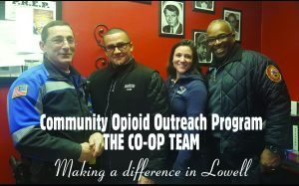The LPD and the City of Lowell applied for several grants through private, state, and federal agencies, and in the fall of 2016, the LPD was awarded funding through the Bureau of Justice Assistance Smart Policing Initiative. With the addition of this funding, the CO-OP team has expanded to include personnel from the Lowell Health Department and the Mental Health Association of Greater Lowell, allowing the team to better serve victims. The CO-OP team also has a partnership with the University of Massachusetts, Lowell (UML) to analyze the data of fatal and non-fatal overdoses to pinpoint possible points along the way in these individuals’ lives where prevention or education strategies could have been applied. Additionally, the data will be used to identify and understand what works and what strategies could be replicated in other cities and towns facing the same problem.
The LPD patrol officers respond to every reported overdose in Lowell. This makes the LPD a natural point of entry for intervention services. Overdose victims receive intervention services through CO-OP. When officers respond to an overdose, they obtain contact information for the victim, which will be documented in the incident report. In the event that a victim is homeless, officers will attempt to find out where the individual can typically be found during the day. The dedicated CO-OP officer reviews overdose incident reports on a daily basis and creates a list of overdose victims that need follow-up home visits.
The LPD’s CO-OP officer works with substance abuse clinicians from the Lowell Health Department, a Lowell firefighter, and substance abuse outreach specialists and recovery coaches from Lowell House to follow up with overdose victims using the contact information obtained by patrol officers. Victims will be contacted within 24–48 hours of their overdose. Research indicates that drug users are more likely to seek treatment shortly after experiencing an overdose, and speaking with someone about treatment after an overdose is positively correlated with seeking treatment.³ Once contact is made, the CO-OP team educates the victim on treatment options and directly connects him or her with services.
Recently, Trinity EMS has joined the team. Trinity EMS is the city’s private ambulance service and responds to all overdose calls. At times, Trinity EMS arrives at a scene first and is off to the hospital when police arrive. Additionally, there are incidents when it is not obvious that the medical call is actually an overdose. This is information that Trinity sometimes acquires while transporting the individual to the hospital. Due to the Health Insurance Portability and Accountability Act (HIPAA) of 1996, Trinity EMS cannot share this information with the LPD; therefore, their addition to the CO-OP team is invaluable as they are able to conduct outreach to the overdose victims that the LPD was not able to document due to lack of information.
The LPD faces an uphill battle with the opioid epidemic. The CO-OP team is highly regarded with this population, and the team members are trusted; nonetheless, they are still rejected by overdose victims on a regular basis. However, the CO-OP team continues to stop by and visit victims even when they have been rejected, and there have been several situations where overdose victims rejected the team numerous times and later took advantage of the services offered.
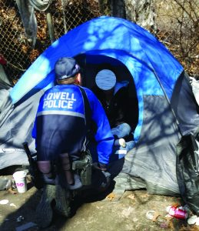All photos courtesy of Lowell, Massachusetts, Police Department.
In one example, the CO-OP team visited a man who overdosed on three different occasions. In one case, this individual was found on the train tracks by other active users who called 911 and used naloxone supplied by the CO-OP team to revive him. After many attempts by the team to get this person into treatment, he finally came around and asked for help. The CO-OP team was able to get him into a detox, shelter, and outpatient program. Any time this individual now makes contact with members of the team, he thanks them for saving his life.
In another example, the CO-OP team attempted to help an individual who overdosed on several occasions, but refused help every time he was approached. This man was running all over the city with different active users, who continued to tell the team that he was going to die from an overdose. The CO-OP team visited his home and educated his mother on how to get a Section 35 for her son. Massachusetts General Law Section 35 allows a family member to involuntarily commit another family member who is an alcoholic or substance abuser to a treatment facility. The mother and the user’s daughter were able to get him committed for treatment.⁴ While he was not happy with the team for educating the family about Section 35, after two weeks in treatment, he reached out to his family and informed them that he was glad the CO-OP team saved his life. He has been clean and sober for over seven months and has even been featured on a local news station to talk about the CO-OP team.
Research indicates that drug users are more likely to seek treatment shortly after experiencing an overdose, and speaking with someone about treatment after an overdose is positively correlated with seeking treatment.
The city has realized a 60 percent reduction in fatal overdoses when comparing January–April 20, 2016 (25 deaths) to January–April 20, 2017 (10 deaths), which is promising.⁵ However, nonfatal overdoses have increased by 13.5 percent when comparing January–March 2016 (155) to January–March 2017 (176), according to Trinity EMS.⁶ One possible reason for the apparent increase in nonfatal overdoses is that more people are willing to call 911 when they witness an overdose, reducing overdose fatalities. Another possibility is that there is an increase in availability of opioids in the community. As part of the ongoing research, the LPD and UML will be able to review a timely analysis of these data. By increasing the capacity of the CO-OP team and partnering with UML researchers to consistently and effectively track data, Superintendent Taylor and city leaders are striving to decrease both fatal and nonfatal opioid-related overdoses and to assist people in accessing treatment services.
Due to the LPD’s community policing and problem-solving philosophy, the agency was selected to be part of the Advancing 21st Century Policing Initiative, which is a small cohort of law enforcement agencies from across the United States that have made significant strides in implementing the recommendations of the 21st Century Policing Task Force report.⁷ The IACP, funded by the Office of Community Oriented Policing Services and in collaboration with CNA, works directly with 15 U.S. law enforcement agencies to document and report their progress on implementing the recommendations of the 21st Century Policing Task Force report. The CO-OP program is just one of the many initiatives the LPD has implemented in order to increase quality of life and improve crime prevention.♦
Notes:
¹Matt Rocheleau, “Opioid Overdoses Far Outpace Car-Crash Deaths in Mass.,” Boston Globe, October 22, 2015.
²The number of both fatal and nonfatal opioid overdoses in 2015 might actually be higher, as numerous cases that involved suspected or potential opioid overdoses have yet to be officially confirmed by the medical examiner.
³Robin A. Pollini et al., “Non-Fatal Overdose and Subsequent Drug Treatment among Injection Drug Users,” Drug and Alcohol Dependence 83, no. 2 (2006): 104–110.
⁴Mass. Gen. Laws Part I, Title XVII, Chapter 14, §35, April 24, 2016.
⁵Lowell Police Department, internal records, 2017.
⁶Trinity EMS, overdose reports, 2017.
⁷Office of Community Oriented Policing Services, IACP, and CNA, Advancing 21st Century Policing Initiative.

Please cite as
William Taylor and Maryann Ballotta, “Community Opioid Outreach Program: A Guardian Mentality Approach to Drug Abuse Intervention and Treatment,” The Police Chief (July 2017): 28–30.
Share this article with anyone using the following URL:
http://www.policechiefmagazine.org/community-opioid-outreach-program-a-guardian-mentality/?ref=2aee5fa3fc50f9a57dc01183d1b85685

